Horse Riding, Penguins & Cape Point Full‑Day Tour
Private Tour | 8–9 Hours | Cape Town
Price: R11,560 total (1–4 guests)
Experience the ultimate Cape Peninsula adventure combining beach horse riding, African penguins, and the world‑famous Cape Point & Cape of Good Hope.
This full‑day tour blends adventure, wildlife, and breathtaking scenery — perfect for couples, families, and nature lovers.
🐎 Noordhoek Beach Horse Riding
Start your day with a scenic drive along Chapman’s Peak before arriving at Noordhoek Beach for a 1–2 hour guided horse ride. Ride along one of Cape Town’s most beautiful stretches of coastline, surrounded by mountains, dunes, and endless white sand.
See Image Link Below
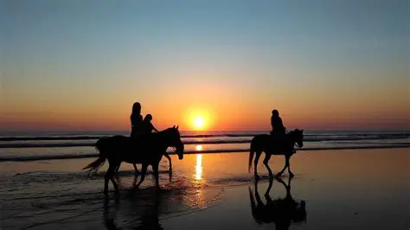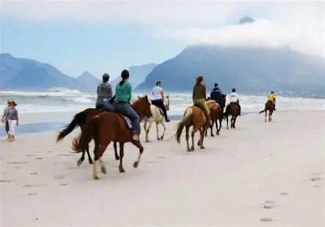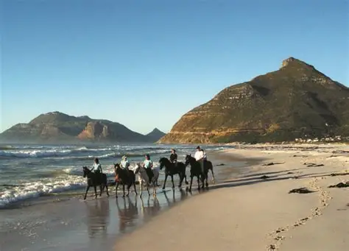
Suitable for beginners and experienced riders
Calm, well‑trained horses
Incredible photo opportunities
Included in the tour price
🐧 Boulders Beach Penguin Colony
Continue to Simon’s Town to visit the famous African penguin colony at Boulders Beach. Walk along the boardwalks for close‑up views of these charming birds in their natural habitat.
See Image Link Below
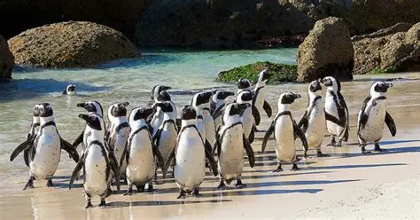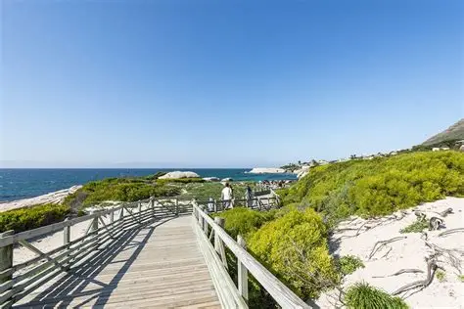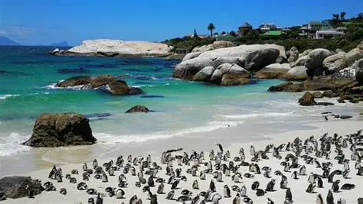
Safe, family‑friendly viewing
Crystal‑clear water and granite boulders
Optional lunch stop at the harbour
Cape Point & Cape of Good Hope
Your journey continues into the Cape Point Nature Reserve, home to dramatic cliffs, wildlife, and iconic viewpoints. Explore the rugged coastline, visit the Cape of Good Hope, and take the funicular up to the lighthouse (optional).
See Image Link Below
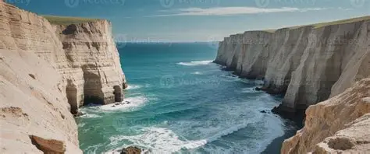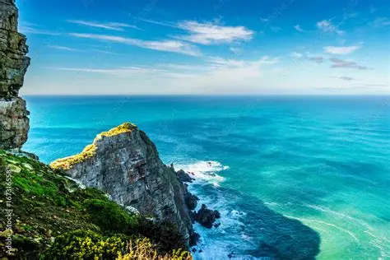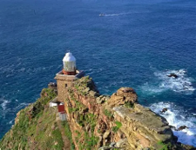
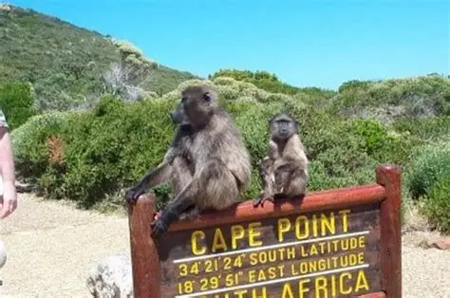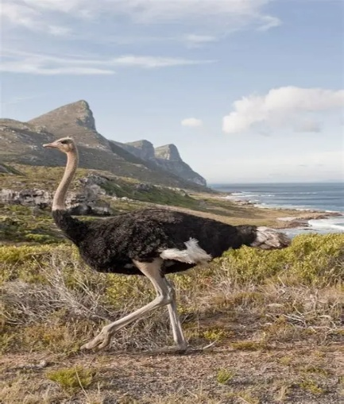
Cape of Good Hope
Cape Point Lighthouse
Wildlife sightings (baboons, ostriches, antelope)
Spectacular ocean views
Tour Highlights
Chapman’s Peak Drive
Noordhoek Beach Horse Riding
Boulders Beach Penguins
Cape Point Nature Reserve
Private transport with driver‑guide
Flexible itinerary

💼 What’s Included
• Private vehicle & professional driver‑guide
• Chapman’s Peak toll fees
• Bottled water
• Hotel pickup & drop‑off
• Horse riding fee
• Boulders Beach entry fee
• Cape Point entry fee
What’s not included
Lunch
🕒 Duration
8–9 hours
Pickup: Cape Town & surrounds
Same Package for 5-7 guests R17,300

